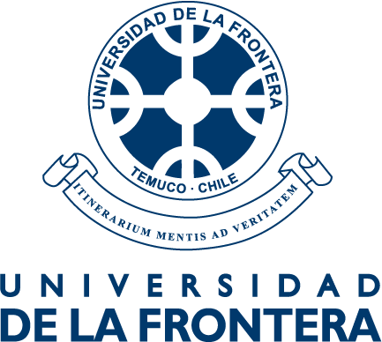
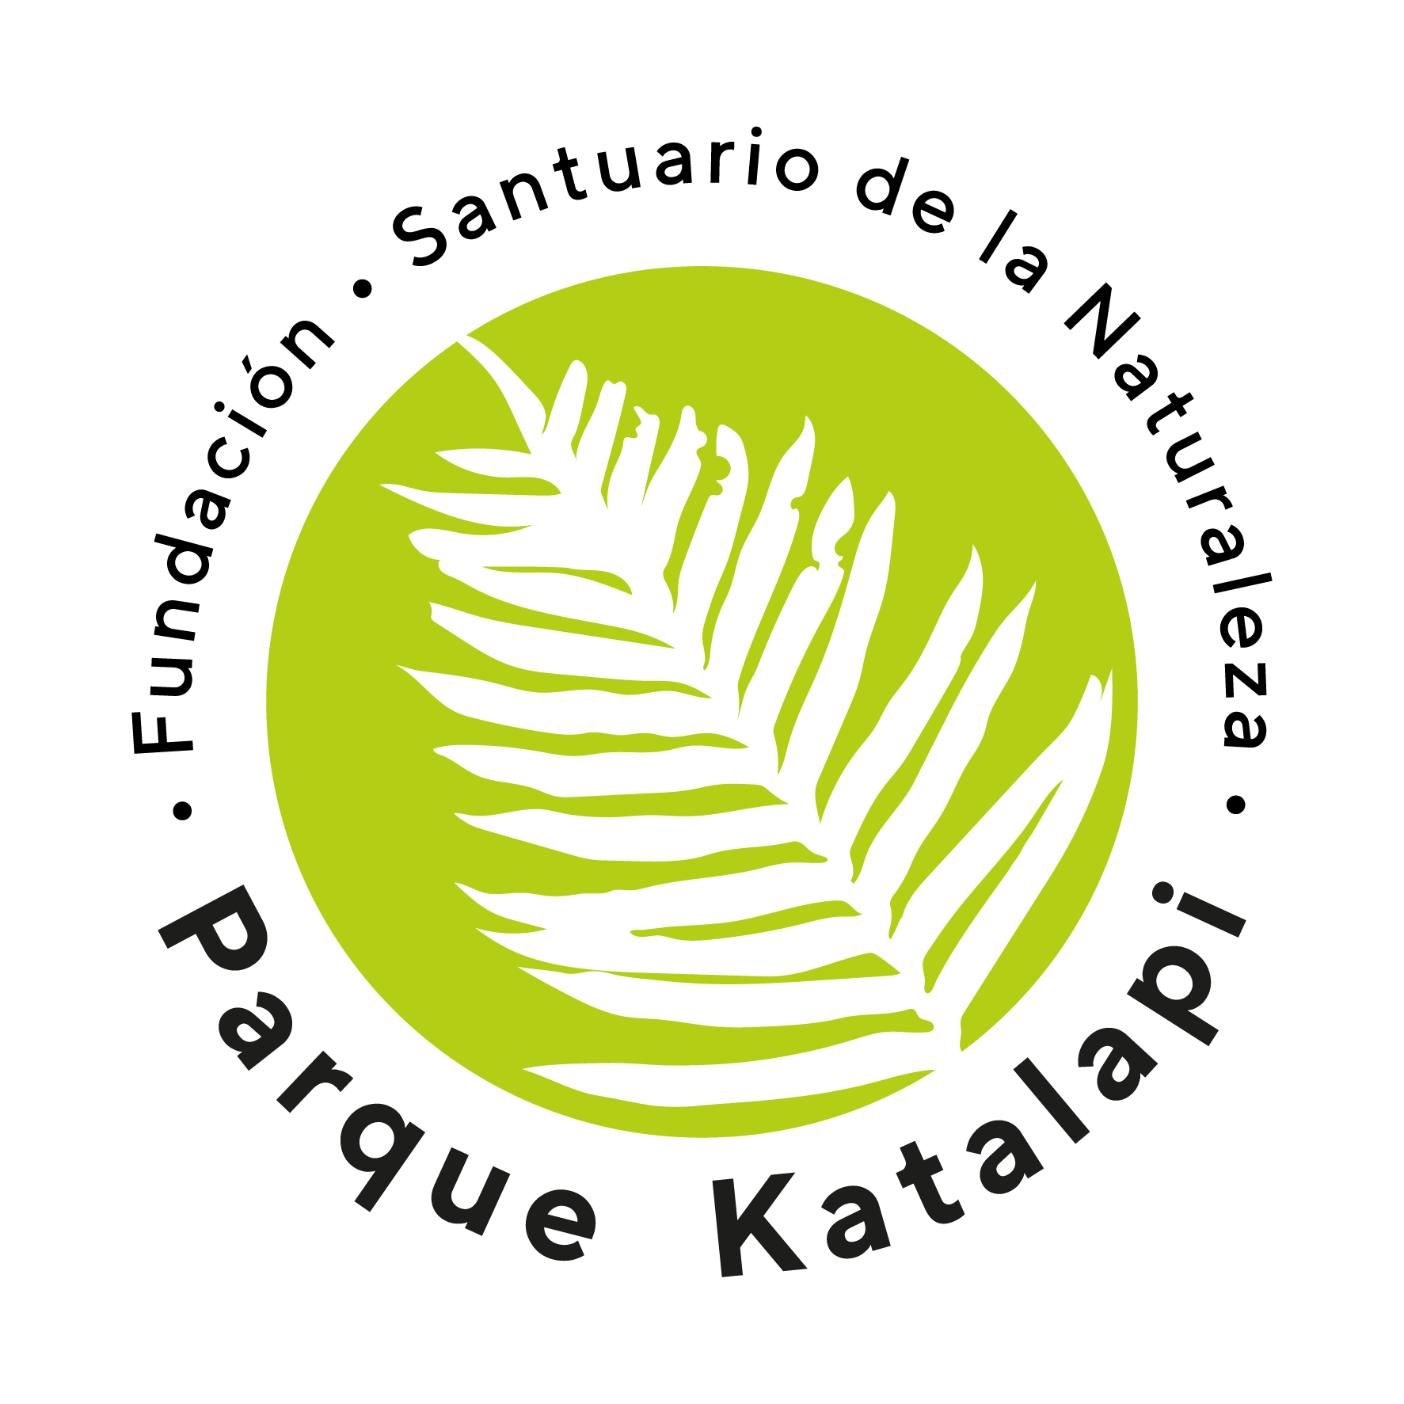
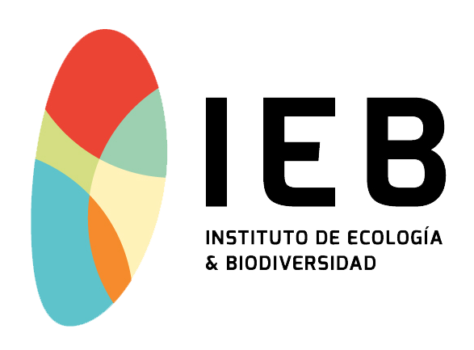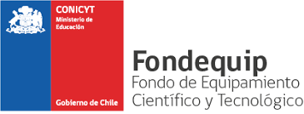
International Colloquium on Plan Ecophysiology
Parque Katalapi, Puerto Montt, Chile; January 18-20, 2023

General Program

Time | Wednesday 18th | Thursday 19th | Friday 20th
8:00-9:00 |  | Breakfast | Breakfast
9:00-9:45 |  | Lecture  Adrienne Nicotra (ANU) | Lecture  Ileana Echeverría (CICY)
9:45-13:00 |  | Short Communications 1 | Short Communications 3
9:45-10:00 |  | Antonio Escandón? | ??
10:00-10:15 |  | Alejandra Flores? | ??
10:15-10:30 |  | Leyla Parra | ??
10:30-11:00 |  | Coffee Break | Coffee Break
11:00-13:00 |  | Mini-lectures 1 | Mini-lectures 2
11:00-11:30 |  | Dariel Lopez | Marely Cuba?
11:30-12:00 |  | Enrique Ostria? | ??
12:00-12:30 |  | Carolina Sanhueza? | ??
13:00-14:30 |  | Lunch | Lunch
15:00-15:45 | GFS-300, WALZ training Katharina Siebke | Afternoon lecture  Jaume Flexas | Closing Lecture  Jeroni Galmés
15:45-17:45 | GFS-300, WALZ training | Symposium Soil-Plant | Departures
15:45-16:15 |  | Francisco Matus
16:15-16:45 | Coffee Break | Coffee Break
16:45-17:15 | GFS-300, WALZ training | Paola Durán
17:15-17:45 | GFS-300, WALZ training | ??
17-45-18:30 | GFS-300, WALZ training | Short Communications 2
17:45-18:00 | GFS-300, WALZ training | ??
18:00-18:15 | GFS-300, WALZ training | ??
18:15-18:30 |  | ??
19:00-… | Cata in Kata/Dinner | Dinner

