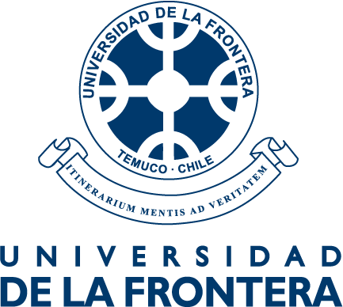
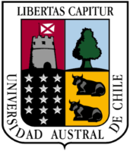

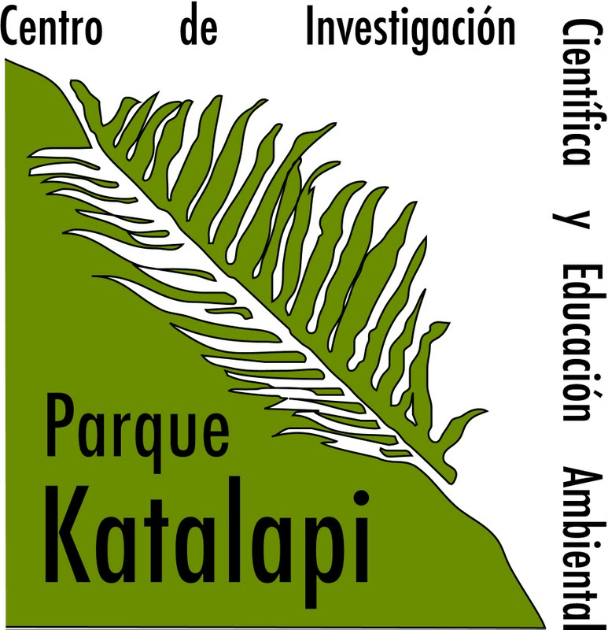

International Course on Ecophysiology of Photosynthesis
Parque Katalapi, Puerto Montt, Chile; January 09-16 2020
Registration instructions:

- A registration fee will cover all basic expenses of the course, including food, lodging in the park from lunch on January 9 until lunch on January 16, 2020. Fees: graduate students $220000 Chilean pesos (about US$324); nonstudents $350000 Chilean pesos (about US$515). Additional dinners cost $7000 pesos each. Additional lodging costs $20.000/day (including breakfast)
- Lodging: student will sleep in bunk beds within the park. Bring sleeping bags. If any participant requires special food, please contact Luis Corcuera by email (luis.corcuera@parquekatalapi.cl) stating your special requirements (ie, vegetarian, diabetic, etc...).
- Weather and clothing: January is Summer time in Chile. Nonetheless, daily temperatures usually oscillate between 10/20°C (min/max). Bring medium-warm clothing, but also be prepared for hot days. It may also rain.
- International students: The registration fee must be paid before November 27, 2019 by wire transfer via Western Union payable to:
Luis Julian Corcuera Pérez (all four names should be included in the transfer)
Phone: +56 9 92490228
Address: Maria Teresa 6286, Depto 307, Las Condes, Santiago, Chile
As soon as you make the transfer please send an email alerting him of the transfer (luis.corcuera@parquekatalapi.cl ) indicating the amount and date and a copy of the receipt of Western Union. If you have any problems to perform the transfer, please do not hesitate to contact him by email or telephone (mobile phone +56 9 9249 0228).
- Students from Chile: the registration fee must be paid before November 27, 2019. For that, make a bank transfer to Luis Corcuera, Rut 5170015-5, Account 160-13571-00, Banco de Chile. Please send a copy of your deposit to luis.corcuera@parquekatalapi.cl
- If you wish to know more about Parque Katalapi, please visit our web page: http://www.parquekatalapi.cl/
- Parque Katalapi is 18 Km from Puerto Montt on Carretera Austral. This park is a Biological station of Universidad de Concepción. Instructions on how to travel to Parque Katalapi from Puerto Montt are in the next pages. This instructive is in Spanish so that, if you ask, anyone could help you. If you need to be picked up at the airport, please contact me. Buses run from the bus terminal to Pichiquillaipe every 30 min. They cost about $650 (about US$1). If you take the bus, please follow instructions on the next page.
- If you need a taxi, we suggest calling José Saldivia (+56 9 7691 9095 phone or whatsapp). He knows Katalapi and will charge a reduced price from the airport (about US$25). Contact him in advance of your flight

