
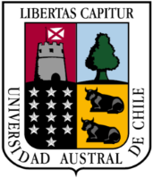

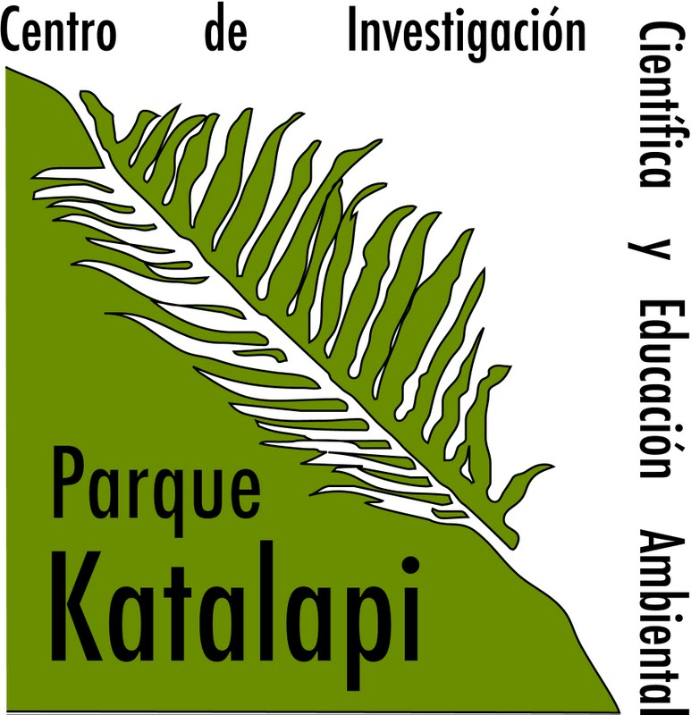
International Course on Ecophysiology of Photosynthesis
Parque Katalapi, Puerto Montt, Chile; January 09-16 2020
Application Form

Name: ..........................................................................................

Institution: ...................................................................................

Country: .........................….... City: ............................................

Email: ...........................................................................................

Graduate Program: Master PhD Not a student

Name of the graduate program and university or place of work for professionals: ...........................……………………………………………………………………………………………….....

Main area of Thesis: .....................................................................

If not a student, indicate profession: ..................................................

English language level: Advanced
Medium
Basic (only reading)

The course will be in English. Students will be required to make presentations in this language.

I (the applicant) will assume the costs of international and national travel to arrive to Katalapi, registration costs, and health insurance with international coverage. Please, attach your curriculum vitae.

Signature: ............................................. Date: ..................................

Registration costs (includes food and lodging):
Graduate students: US$324/$220000 Chilean pesos
Professionals: US$515/ 350000 Chilean pesos
Send the filled registration form to leon.bravo@ufrontera.cl
To be sent before October 15, 2020

