
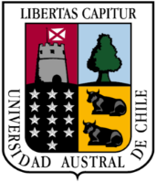

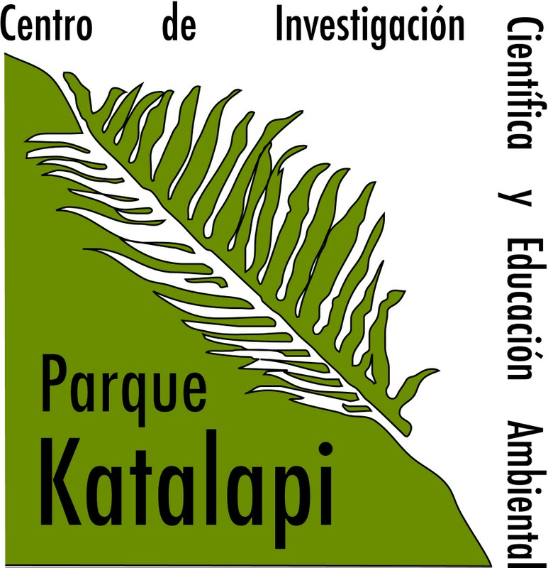

Ecophysiology of Photosynthesis: Theoretical and practical approaches

Course Description:
The First version of this course was in January 2010. This new version will consider 84 hours of lectures, practical training and field research work (3STC) covering topics in photosynthesis from laboratory to the field. Practical sessions on gas exchange and fluorescence measurements will be an important part of the course. This course is designed as an intensive immersion experience. It requires stamina, endurance, social skills, and patience.

Main Topics:
Photosynthesis: Light capture and energy conversion.
Regulation of carbon dioxide diffusion inside leaves and carbon assimilation.
Photosynthetic WUE: insights into stomata regulation.
Rubisco and its pivotal role in photosynthesis.
Plant Respiration: Interaction with Photosynthesis.
Characterization of plants from different light environments.
Photoinhibition and photoprotective mechanism.
Antioxidants in plants and their importance in photosynthesis.
Modelling Photosynthesis.
Phytohormones and photosynthetic regulation.
Carbon Partitioning and sink to source relations.
Evolution of photosynthesis: variation of leaf photosynthetic traits accross plant's phylogeny
Photosynthesis through the canopies I: Theoretical overview.
Photosynthesis through the canopies II: Modelling and exercises.
Remote sensing and photosynthetic phenology.

